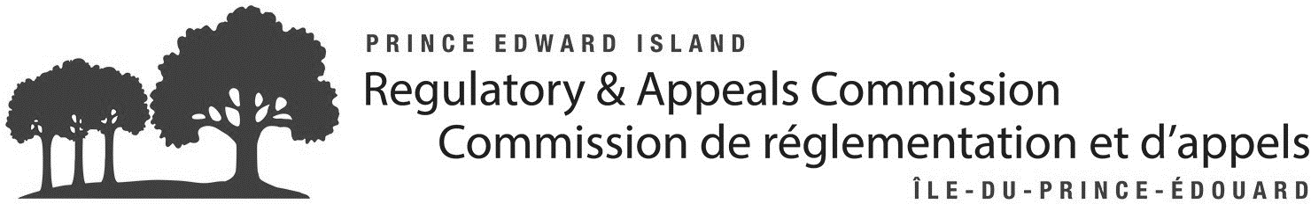
Notice of Application
Rate Increase
Victoria Water and Sewage Commission
Sewer & Water Rates
The Victoria Water and Sewage Commission (the “Utility”) has applied to the Prince Edward Island Regulatory & Appeals Commission (the “Commission”) requesting sewer and water rate increases for the 12-month period ending March 31, 2023.
SPECIFICALLY, THE UTILITY PROPOSES the following yearly unmetered rates, per unit:

Rates | CURRENT: | PROPOSED :
Unmetered Water | $304.00 | $350.00
Water Frontage | $152.00 | $175.00
Sewer | $552.00 | $635.00
Sewer Frontage | $276.00 | $318.00

DETAILS OF THE RATE APPLICATION and the Utility's current sewer and water rate tariffs can be viewed on the Commission website at irac.pe.ca/utilities. Questions on the filing should be addressed to the Victoria Utility.
IF YOU WANT TO COMMENT on the application, you can write or email the Commission at the address below. Questions on the application should be sent directly to the Utility at the address below.
Written comments are due by January 27, 2023.
THE COMMISSION’S RATE REVIEW PROCESS:
- Utility files a rate application;
- Public notice of the Utility's proposed rate changes;
- Commission review of the application and written comments; and
- Commission Order outlining the decision and the rates to be charged.
Decisions on the Utility's application can be found on the Commission website at irac.pe.ca/utilities.
Contact Information:
UTILITY –  Hilary Price,  Chief Administrative Officer  Victoria Water and Sewage  Commission  P.O. Box 7  730 Victoria Road  Victoria, PE C0A 2G0  Tel: 902-658-2541  Email: victoriamunicipalitypei@gmail.com | COMMISSION –  Re: Victoria Rate Filing  The Island Regulatory and Appeals Commission  P.O. Box 577  Charlottetown, PE C1A 7L1  Tel: 902-892-3501  Toll Free: 1-800-501-6268  Email: water-sewerinquiries@irac.pe.ca

DATED at Charlottetown, this 10th day of January, 2023.

